#LESSON PLAN
The lesson will begin with a discussion on why data compression is important in everyday computing. Students will explore lossless and lossy compression methods with simple examples to understand their differences. The lesson will conclude with a demonstration of file size reduction using tools like WinRAR and 7-Zip.
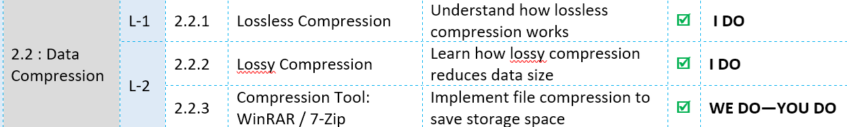

#STARTER
What problems do we face if data is not compressed, especially with large files like images, audio, and video? How does compression help in saving storage space and speeding up data transmission over the internet? What might be the difference between reducing file size and losing information from the data? In what real-life situations do we use compressed data every day without realizing it? What challenges or trade-offs might arise when compressing data too much?


# LESSON OBJECTIVES
We will learn about Lossless Compression and how data is compressed without losing any information, We will learn about Lossy Compression and how some data is removed to greatly reduce file size.
We will learn about File Size Reduction and why smaller files are easier to store and transmit, We will learn about WinRAR / 7-Zip and how these tools are used to compress and extract files.

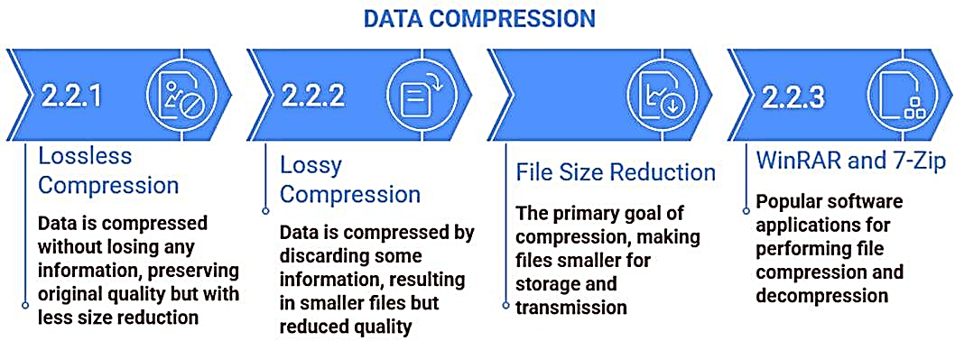

#2.2:DATA COMPRESSION
Data compression reduces file size, allowing information to be stored and transmitted more efficiently while using less storage space and bandwidth. It is commonly applied to images, audio files, video streaming, and storage systems. The compression
process works by eliminating redundant data or applying efficient encoding methods. As a result, data can be represented using fewer bits than its original form. This leads to improved storage efficiency and faster data transfer within computer systems.
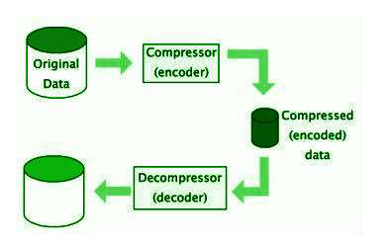

#2.2.1: Lossless Compression
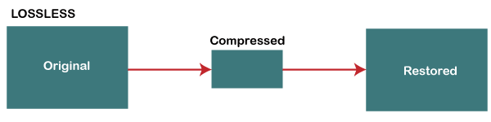
Lossless compression decreases file size while keeping all original data intact, making it possible to recreate the exact original file after decompression. This method works by detecting repeating patterns and data redundancy without discarding any information. It is especially important when accuracy and data integrity must be maintained. Common uses include text files, spreadsheets, and program files. A real-world example is zipping a Word document and later extracting it with no changes to its content. Another example is PNG images, which preserve full image quality even after compression and decompression.

#2.2.1: Run-Length Encoding (RLE)
This method replaces repeated values with a count and a single symbol; for example, “AAAAAABBB” is encoded as “6A3B”. It is most effective when data contains long sequences of identical values, such as simple graphics, icons, or monochrome images. However, when data has high variability, this approach can increase file size, since storing “1A1B1C” requires more space than “ABC”.
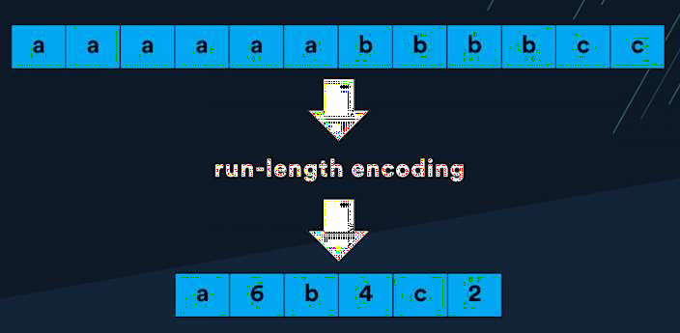

#2.2.1: Huffman Coding

This technique assigns shorter binary codes to frequently occurring symbols, so a common letter appearing many times (e.g., 1000 times) might use a 2-bit code, while a rare letter is assigned a longer code, such as 12 bits.
This method constructs a binary tree based on symbol frequencies to calculate optimal code lengths, ensuring that no code is a prefix of another. It forms the basis for file formats such as ZIP and PNG, and learning this algorithm helps explain how lossless compression achieves efficient size reduction.

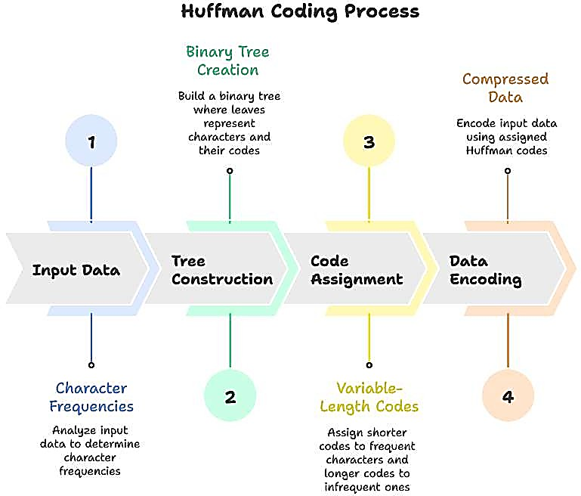

#2.2.2: Lossy Compression: (Jpeg)
Lossy compression achieves higher compression ratios by permanently removing data considered less important. Image compression reduces the size of image files so they occupy less storage space. JPEG (Joint Photographic Experts Group) is a widely used format for storing and sharing photos. It works by slightly removing details that are difficult for the human eye to notice, keeping the image quality clear while reducing file size.
For example, when you take a photo on your smartphone and share it on WhatsApp, it is saved or sent as a JPEG to make it smaller and faster to send. JPEG compression also allows faster uploading and downloading of images and is commonly used on websites to load images quickly and save internet bandwidth.
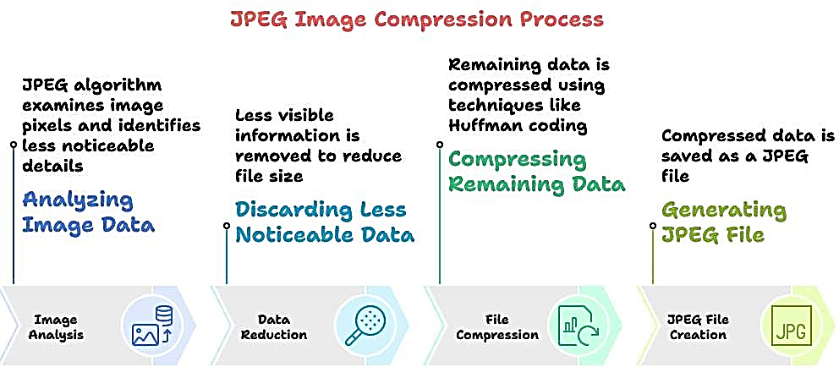

.

#2.2.2: Audio Compression (Mp3)
This compression method removes audio frequencies that humans cannot hear or sounds that are masked by louder nearby noises, a process called perceptual coding. It uses psychoacoustic principles to focus on the sounds that are most important to human hearing. As a result, MP3 files are much smaller than the original audio while still maintaining acceptable sound quality. MP3 compression can achieve about a 10:1 reduction in size, making music streaming and playback faster and more efficient.
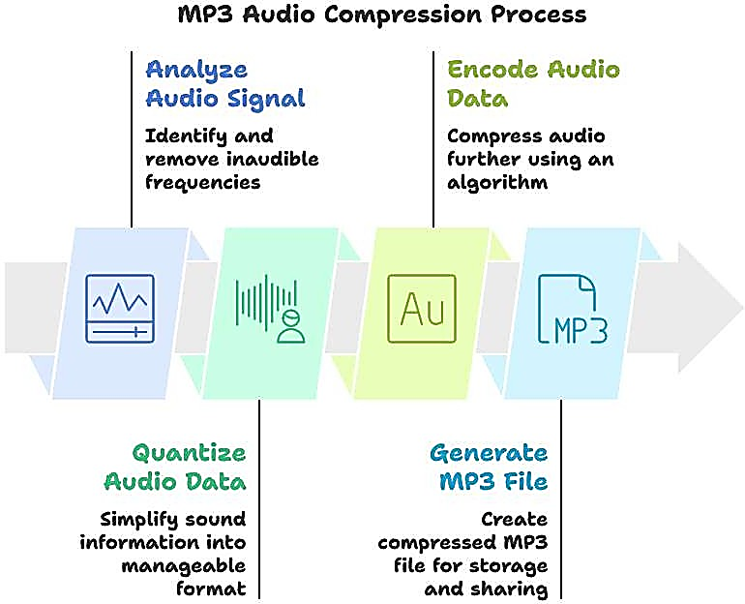
For example, when you listen to songs on Spotify or download music to your phone as MP3 files, the audio is compressed so it takes up less space and plays smoothly.

#2.2.2: Video Compression (Mpeg)
MPEG (Moving Picture Experts Group) reduces the size of video files by removing redundancy between frames. When only a small portion of a scene changes, only those changes are stored. MPEG is crucial for video streaming and storage, because without it, a single HD movie would take up hundreds of gigabytes. It uses motion estimation to
follow moving objects and record only the differences between frames. Additionally, entropy coding is applied to further compress the data while preserving important details..
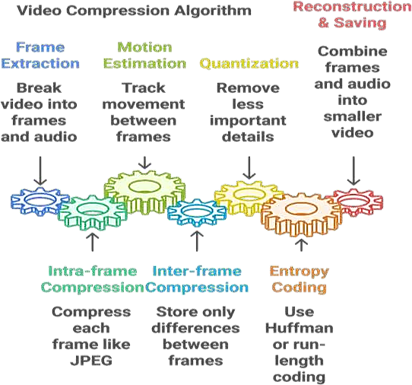
Example: When you watch a movie on Netflix or YouTube, the video is compressed using MPEG so it plays smoothly and saves internet bandwidth.

#2.2.3: File Compression Tool-Winrar / 7-Zip
WinRAR and 7-Zip are file compression tools that reduce the size of files or folders by removing redundant data.
They create compressed archives (like .rar or .zip) that are easier to store or share.

Uses:
Save storage space on your computer.
Make it easier to send large files via email or messaging apps.
Protect files with passwords and encryption.
Combine multiple files into a single archive for organization.

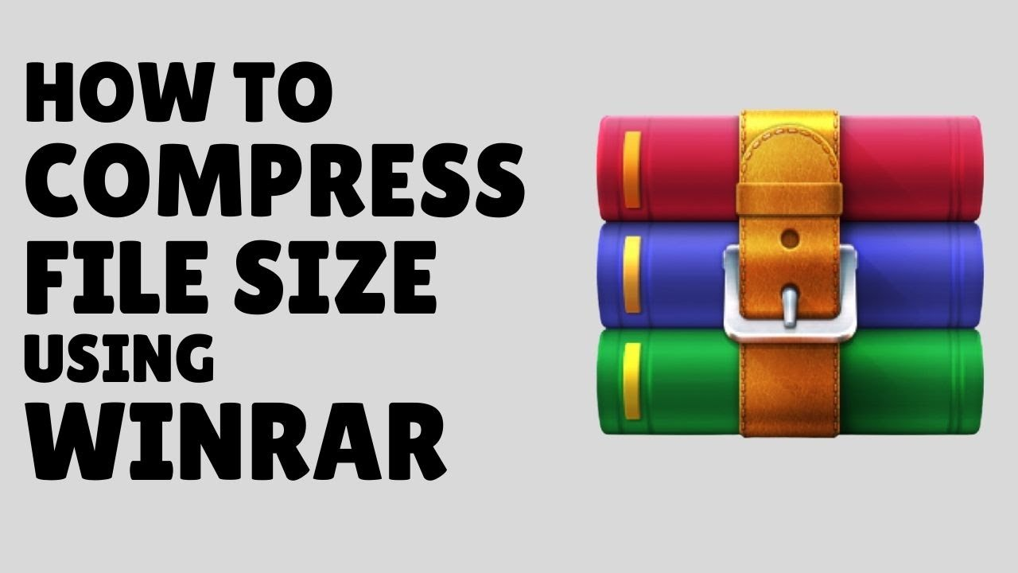

#Lab-WK-2-L1:File Compression
You have a large collection of files on your computer that needs to be shared via email or stored efficiently.
Task: Use WinRAR or 7-Zip to compress the files into a smaller archive.
- Choose a compression format and level.
- Save the compressed archive in a convenient location.
- Check the new file size and compare it with the original total size.
.Steps to Compress Files using WinRAR / 7-Zip:
Step 1: Select Files – Highlight the files or folders you want to compress – Step 2: Right-Click – Right-click the selection and choose Add to archive… (WinRAR) or 7-Zip → Add to archive… –
Step 3: Choose Format – Select the compression format (e.g., .zip, .rar) – Step 4: Set Compression Level – Pick a compression level (e.g., normal, high) –
Step 5: Confirm – Click OK to create the compressed archive –
Step 6: Check Archive – The new compressed file appears in the chosen location –
Step 7: Compare Sizes – Compare the compressed file size with the original to see the reduction.

#LESSON SUMMARY
Data compression helps reduce the size of files so they take up less storage space and can be shared faster. There are two main types of compression: lossless, which keeps all data intact, and lossy, which removes some data to achieve higher compression. Tools like WinRAR and 7-Zip are commonly used to compress and extract files efficiently.
